


Tour of
Web-Based Resources


Free Online Tools to Support Effective Instruction

Tour of Web-Based Resources
Presentation

The Intel® Innovation in Education Institutes Web resources contain all the materials you need to present a successful presentation including:
- This document
- Workshop slides (online or PDF)

NOTE: If you have Internet access in the room where you will be giving the presentation, you can view the slides online. If you don’t have Internet access, then use the PDF version of the slides to give the presentation.

NOTE: There are no participant handouts for this workshop.

These presentation materials assume that you:
- Have education experience in the classroom
- Have thoroughly reviewed and are familiar with the presentation resources
- Have thoroughly reviewed and are familiar with the Intel® Innovation in Education Web site (www.intel.com/education)
- Are familiar with using the Internet

Technical Requirements
To give the presentation, you’ll need:
- Presenter's workstation equipped with:
- Windows Media Player*
- High-speed Internet connection (optional)
- Screen
- Computer projector
- Speakers (or speakers on the computer projector)
- VCR to view It’s a Wild Ride video and the video
- Wireless mike (depending on room size and acoustics)

For more information, on the computer requirements, see Site Recommendations www.intel.com/education/site_support/recommendations.htm

Preparation
Make sure you have spent time going over the Intel® Innovation in Education Web site before your presentation so you are familiar with its layout and content.

Prepare for video viewing by ordering the It’s a Wild Ride video (on VHS-We don’t have it available on CD, yet.).Since we don’t have the CD, this doesn’t apply.

Day of the Presentation
If you have an Internet connection for the presentation:
- Open two browser windows on the presenter’s workstation. During the presentation, you will use one browser for the presentation slides and the other for the Intel® Innovation in Education Web site. You’ll toggle between these browser windows during the presentation.

If you do NOT have an Internet connection for the presentation:
- Download the PDF version of the presentation slides to your computer.
- Use the PDF version of the slides to give the presentation.

Tour of Web-Based Resources
Presentation

Goals
- Increase educators’ awareness about Intel’s efforts in education
- Provide educators with online resources that can be used for instructional purposes
- Disseminate seed ideas, online tools, and strategies for using technology in motivating and instructional methods

Agenda
Total Estimated Time: 1 hour
Topic | Estimated Time | Slide Numbers
- Welcome | 3 minutes | Slides 1–3
- Overview and Goals | 3 minutes | Slides 4–5
- Educators’ Online Resources | 4 minutes | Slides 6–8
- Seed Ideas for Effective Technology Integration | 10 minutes | Slides 9–10
- Detailed Project Plans | 5 minutes | Slides 11–12
- Detailed Case Study | 7 minutes | Slides 13–14
- Interactive Online Tools | 12 minutes | Slides 15–21
- Strategies for Using Emerging Technologies | 5 minutes | Slide 22
- Developing Interest in Engineering | 5 minutes | Slides 22–24
- Workshops Support Learning With Technology | 3 minutes | Slides 25
- Wrap Up | 3 minutes | Slide 26

Facilitator Tips During the Workshop

Slide 1

Key Points Notes
Time: 3 min. Slides 1–3

Display this slide as participants enter the room.

Introduce yourself and have participants introduce themselves, if appropriate,

Slide 2
About Intel in Education
The Intel® Innovation in Education initiative:
- Has invested more than $700 million worldwide in education efforts through 2003
- Collaborates with leaders from education, governments, industry, academia, and research organizations
- Designs and delivers programs in more than 50 countries on six continents
- Gives teachers tools, strategies, and resources, free-of-charge, that they can use to make a difference in the classroom
This long-term, sustained initiative consists of several programs:
- Intel® Innovation in Education Web site
- Intel® Teach to the Future
- Intel Computer Clubhouse Network
- Intel sponsored science competitions
  - Intel Science Talent Search (Intel STS)
  - Intel International Science and Engineering Fair (Intel ISEF)
Key Points Notes
Time: 3 min. Slides 1–3

Provide an overview of Intel’s efforts in and commitment to education worldwide.

Point out that Intel does not sell directly to teachers, however, it is in the company’s interest to have teachers use technology well and in ways that benefit students’ education.

Slide 3
Intel® Innovation in Education Web Site
Intel® Innovation in Education home page
www.intel.com/education
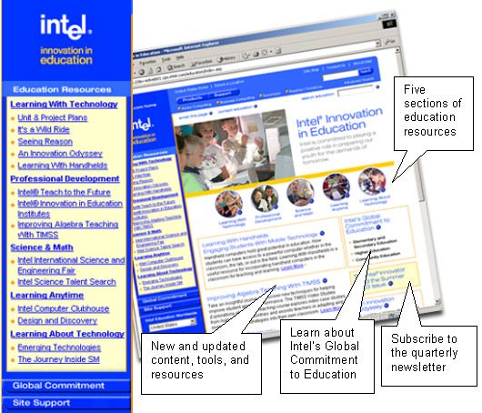
Key Points Notes
Time: 3 min. Slides 1–3

Display the Intel® Innovation in Education Web site home page to make participants familiar with it as a source of Intel resources for educators.

Explain that the Web site is a compilation of informed commentary, articles, online tools, lesson and unit plans, and educational strategies, all designed for educators to use as resources in support of, and within, their classes.

Slide 4
Overview and Goals
The purpose of this workshop is to show you various parts of the Intel® Innovation in Education Web site and to share with you:

- Intel’s efforts in education
- Online tools and resources that can be used for instructional purposes

Key Points Notes
Time: 3 min. Slides 4–5

Present the goals of the presentation.

Explain that the Intel® Innovation in Education Web site is a free Web-delivered resource. It is not an online course.

Slide 5
Agenda

Educators’ Online Resources
- What’s on the Web Site?
- What the Resources Provide
Seed Ideas for Effective Technology Integration
- An Innovation Odyssey
Detailed Project Plans and Case Study
- Unit Plan and Project Plans
- Technology-Supported Project Learning With It’s a Wild Ride
Interactive Online Tools
- Ranking tool With Resources for the Classroom, Visual Ranking
- Supporting Cause-and-Effect Thinking, Seeing Reason an Online Mapping Tool

Strategies for Using Emerging Technologies
- Learning With Handhelds
- Syndication
Developing Interest in Engineering
- Design and Discovery
Professional Development Workshops Support Learning With Technology
Wrap Up

Key Points Notes
Time: 3 min. Slides 4–5

Briefly present the agenda and what will be covered in the presentation.

Slide 6
Educators’ Online Resources

What: A Web site that provides resources, tools, and strategies
(more than a marketing tool)

Who: A worldwide team of educators as well as technology experts and innovators
(Intel's core competencies)

How: We collaborate with other educators, education organizations, and governments worldwide to build and deliver high-quality resources
(free)

www.intel.com/education
Key Points Notes
Time: 4 min. Slides 6–8

Explain that the Intel® Innovation in Education Web site provides resources, tools, and strategies that support effective practices in technology integration.

- The Intel® Innovation in Education Web site is a free resource for educators.
- The site is developed by an extended team with expertise in education, technology, and innovation, and taps into educators’ networks worldwide to extend ideas and materials to other educators and students.

Explain that Intel is involved in education to:

- Prepare young people for a knowledge-based economy
- Help students develop higher-level thinking skills

Slide 7
What’s on the Web Site?

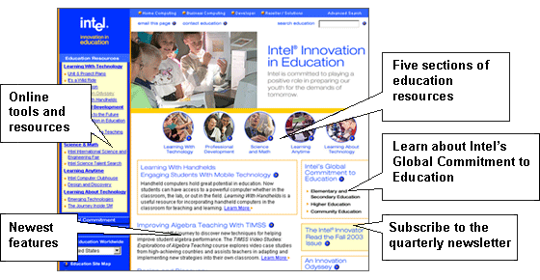

Key Points Notes
Time: 4 min. Slides 6–8

Describe how the Web site is organized in sections, starting with the right side, covering the middle, and then the left channel.

- The right side includes links to Intel’s Global Commitment to Education.
- Global Tour includes stories of impact from over 20 worldwide locations.
- Beneath the Global Tour link is a sign-up for a quarterly education newsletter with stories about the use and impact of Intel education resources. Encourage them to sign-up for the newspaper to receive notification of new resources, tools, and updates to existing tools, resources, and programs.
continued on next page

- Across the middle are highlights of the most recent content.
- Across the page and in the left-hand channel are links to five main areas. This presentation focuses on thee sections: Learning With Technology, Professional Development, and Learning Anytime.
- In the Science and Math section, the Intel Science Talent Search competition is for high school seniors; and the Intel Science and Engineering Fair is designed for students in grades 9–12.
- Near the bottom of the left channel is a link to Learning About Technology, which explains, among other things, how a microchip is made.

Slide 8
What the Resources Provide

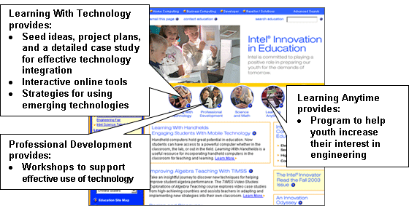

Key Points Notes
Time: 4 min. Slides 6–8

Explain what tools and resources can be found in three of the sections of the Intel® Innovation in Education Web site.

The Learning With Technology section of the Web site provides:
- Seed ideas, project plans, and a detailed case study for effective technology integration
- Interactive online tools
- Strategies for using emerging technologies

The Professional Development section provides workshops to support effective use of technology.

The Learning Anytime section provides a program to help youth increase their interest in engineering.

Slide 9
Seed Ideas for Effective Technology Integration
An Innovation Odyssey:
- Is a collection of stories about teachers who use technology well
- Includes stories submitted by teachers from around the world—cross-discipline and across grade levels
- Showcases multiple technologies and uses
- Inspires technology-comfortable teachers and may convince reluctant teachers and parents
- Allows you to syndicate An Innovation Odyssey to your school Web site to automatically deliver good ideas

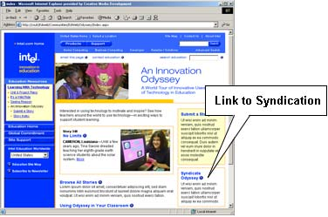

Key Points Notes
Time: 10 min. Slides 9–10

Explain the following about An Innovation Odyssey:
- Odyssey stories offer teachers ideas centered on effective technology integration and project-based learning.

- It is an atypical collection of over 300 international stories about technology integration in education.

NOTE: If you are giving this presentation to educators from a specific content area, you may want to indicate the number of stories about that content or give specific examples.
continued on next page

- An Innovation Odyssey is an excellent showcase of technology integration in the classroom. (Administrators can use this to show parents and the community what effective technology integration in education looks like.)

Explain that syndication automatically updates your school or class Web site with fresh content from An Innovation Odyssey, which is an attractive feature for those responsible for updating teaching and learning Web sites.

Slide 10
Anatomy of An Innovation Odyssey Story
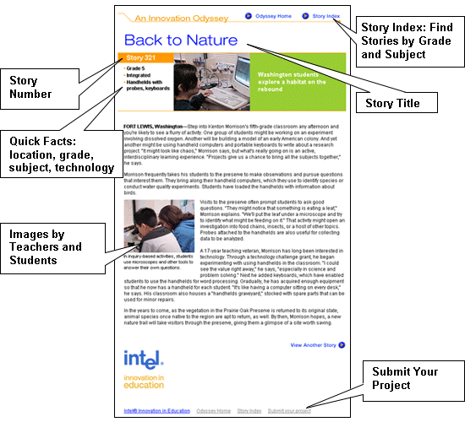
Key Points Notes
Time: 10 min. Slides 9–10

Explain that presenter (this presentation is geared for participants that do not have computers) will examine the structure of one story in An Innovation Odyssey.

Point out items on the slide (place emphasis on Submit Your Project):
- Story Index: Find Stories by Grade and Subject
- Story Title
- Story Number
- Quick Facts
- Images
- Submit Your Project

Slide 11
Detailed Project Plans

The Web site contains detailed project plans for effective technology integration.

Exemplary project plans include:
- Comprehensive materials for use
- Technology integration focus
- Format and structure from Intel® Teach to the Future
- All disciplines and grades

Key Points Notes
Time: 5 min. Slides 11–12

Explain that the Web site holds detailed unit and project plans, across grades and curricula. The plans were developed by classroom teachers as part of the Intel® Teach to the Future professional development training and can be used as “seed ideas” or they can be implemented “as is.”

Slide 12
Anatomy of a Unit Plan
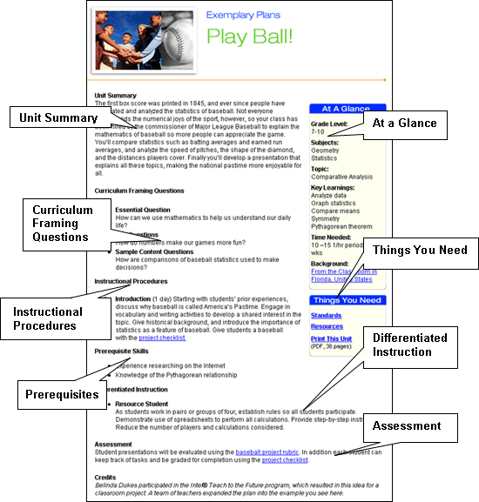
Key Points Notes
Time: 5 min. Slides 11–12
Explain the Unit Plan features:

- Curriculum framing questions, including top-level essential questions, unit-related questions, and some sample content questions.

- Step-by-step instructional procedures with handouts, student work samples, and links to other Web sites.

- Prerequisite skills and differentiated instruction
continued on next page
- Assessment strategies, including rubrics and worksheets

- At-a-glance descriptive features, such as grade levels, subjects, topic, key learning points, time required, and background of the classroom and/or teacher for context.

- Connection to standards—National and state standards are addressed at higher levels, not at the content level. The standards are aligned and recognizable across states and teaching materials.

- Modifiable versions of associated files, if needed to customize the plan.

Slide 13

Detailed Case Study

The Web site includes a detailed case study for effective technology integration.

It’s a Wild Ride Case Study:
- Has elements of middle school math, science, social studies, and language arts
- Is an extended project that involves students in designing a roller coaster
- Includes a free video that introduces the project

Key Points Notes
Time: 7 min. Slides 13–14

Explain that It’s a Wild Ride is an in-depth, project-based learning case study with the features listed on the slide.

Describe the introductory video, and how it is to be used in the project.
- The video does an excellent job of introducing the project.
- The video is free. You can order copies from the It’s a Wild Ride Web page.

OPTIONAL (if time permits)—Show the It’s a Wild Ride video (15 minutes).

Slide 14
It’s a Wild Ride
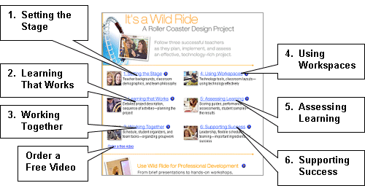
Key Points Notes
Time: 7 min. Slides 13–14

Review the main sections of the It’s a Wild Ride case study:

- Setting the Stage—Teacher backgrounds and teaming; classroom demographics; team philosophy
- Learning That Works—Project description and contents; student work; sequence of activities—planning the project
- Working Together—Daily calendar of project activities; student organizers (red book); team tasks—grouping
- Using Workspaces—Technology tools; classroom layouts
- Assessing Learning—Scoring guides; performance assessments; student samples
- Supporting Success—Block schedule; teaming; leadership
[PROGRAMMER: New Slide]

Slide 15
Interactive Online Tools

- Address higher order thinking
- Support discussion and refinement of thinking
- Encourage students to dig into complex ideas with greater clarity
- Are usable in any subject and grade level (with sufficient verbal skills)
- Provide supporting resources for building projects

Key Points Notes
Time: 12 min. Slides 15–21

Introduce the interactive online tools, covering the points listed on the slide.

Mention that they will learn about two interactive online tools:
- Visual Ranking
- Seeing Reason

Slide 16
Visual Ranking

Visual Ranking is an online ranking tool that allows students to:
- Arrange factors in an ordered list
- Explain their reasoning through comments
- Compare their results with lists made by others

The Visual Ranking tool supports high-order skills including analysis, evaluation, and decision making.

Key Points Notes
Time: 12 min. Slides 15–21

Explain that Visual Ranking is a new interactive online tools on the Intel® Innovation in Education Web site.

NOTE: To view the Visual Ranking resources, go to
www.intel.com/education/visualranking.

Review the points listed on the slide.

Slide 17
Visual Ranking Tool

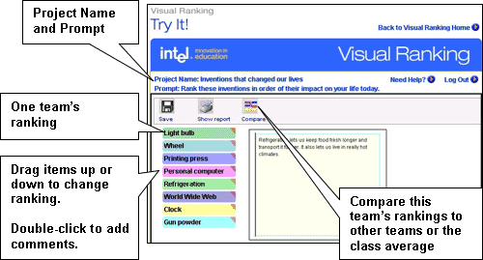

Key Points Notes
Time: 12 min. Slides 15–21

Explain the basic functions of the Visual Ranking tool.
Emphasize that the Comments field allows students to explain their reasoning, along with listing any relevant research data.

Explain that the Visual Ranking tool helps students set priorities, debate differences, make correlations, reach consensus, and organize ideas. Provide examples of how it might be used in a classroom.

Point out that the Visual Ranking tool, like Seeing Reason, is available free-of-charge from any computer connected to the Internet.

Mention that Seeing Reason and Visual Ranking are currently available and that other tools are coming soon. All tools will continue to focus on higher-order cognitive skills.

Slide 18
Teacher Workspace

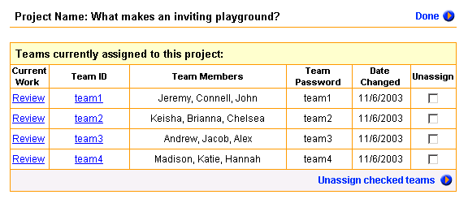
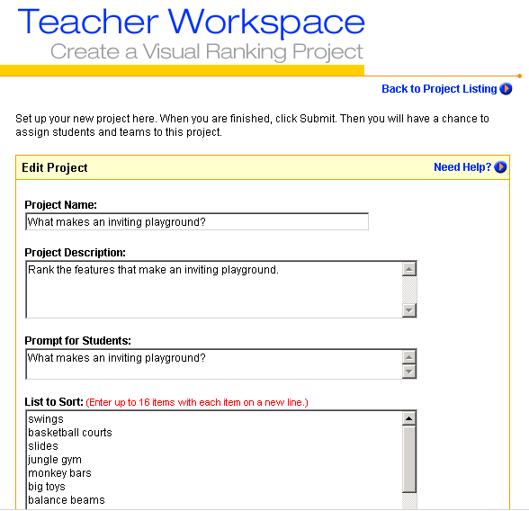
Project Name
Description
List of Items to Sort
Prompt for Students

Teams

Key Points Notes
Time: 12 min. Slides 15–21

Make clear that teachers can access all online tools from the Teacher Workspace.

Explain that the Teacher Workspace landing page permits teachers to setup the following:
- Project name and description
- Prompt for students (It appears at the top of the Visual Ranking page where they sort the items.)
- List the list of items for students to sort

Explain that Teacher Workspace provides a summary of all of the teacher’s teams and their projects.

Slide 19

Seeing Reason
Seeing Reason is an online mapping tool that shows cause-and-effect relationships. The Seeing Reason tool:
- Is research-based and was developed at Berkeley
- Supports interactive collaboration
- Allows teachers to see students’ thinking over time
- Provides teacher and student workspaces for setting up class projects and saving maps

Key Points Notes
Time: 12 min. Slides 15–21

Explain that Seeing Reason is the second of a suite of online tools on the Intel® Innovation in Education Web site. NOTE: Not sure if we should call this out as the second or the first, since it will be presented after VR per the slides? Katherine, what do you think?

Review the points listed on the slide.

Slide 20
Seeing Reason Tool
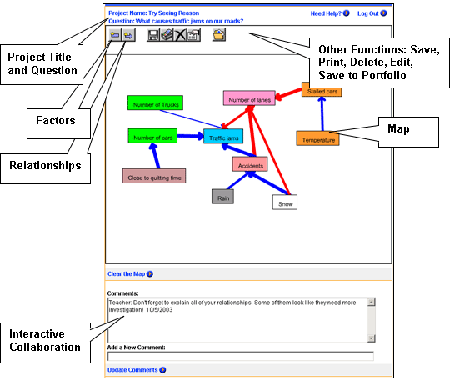

Key Points Notes
Time: 12 min. Slides 15–21

Explain features of the displayed map:
- Factors
- Relationships
- Arrows
- Colors

Point out that the tool is designed to:
- Use Comments as a means of interactive collaboration
- Allow teachers to see how students’ thinking evolves over time with the Portfolio and Save buttons

Slide 21
Factors and Relationships

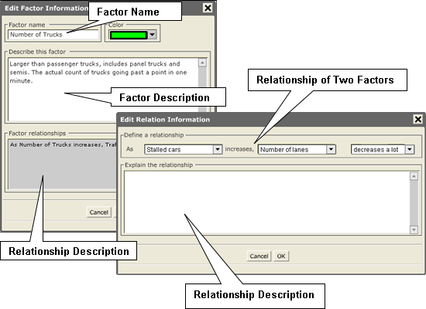

Key Points Notes
Time: 12 min. Slides 15–21

Describe the purpose and use of each field in the Factor Information portion of the tool. Emphasize that the Description of Factor field allows students to explain their reasoning, along with listing any relevant research data.

Explain how students can use the Relation Information section to indicate relationships between and among factors. Review how drop-down menus work with Relationship Factors.

Slide 22
Strategies for Using Emerging Technologies

Support for the adaptation of new technologies for the benefit of education:
- Handhelds
- Syndication

Key Points Notes
Time: 5 min. Slide 22

Explain that the Intel® Innovation in Education Web site covers the following topics.

Learning With Handhelds
- About Handhelds—Covers cost profiles; software; hardware; and FAQs
- Managing Handhelds—Addresses managing in schools; managing in classrooms; and managing in learning
- Teaching With Handhelds—Provides strategies for introducing handhelds in the classroom; “how to use” ideas around data collection; how to engage students with handhelds
- 18 unit plans are available for downloading on a handheld, as is a white paper on the research around using handhelds in education.

Syndication
- Syndication permits automatic delivery of Web site content. (This was briefly covered earlier in the presentation in An Innovation Odyssey.)

Slide 23
Developing Interest in Engineering

Design and Discovery is a curriculum and supporting resources for implementing a pre-engineering program for youth, ages 9–14.

- Design and Discovery is a hands-on, inquiry-based experience with designing creative solutions to everyday problems.
- It introduces students to design and engineering concepts.
- Students follow a design process and build prototypes of their ideas.
- Students prepare and share the results of their work in a science or mini-engineering fair.

Key Points Notes
Time: 5 min. Slides 22–24

Explain that Design and Discovery is a free curriculum delivered online. (It is not an online course).

Point out that the curriculum is designed to interest students in engineering through the design process and is ideal for an after-school or enrichment program.

Review the points listed on the slide.

Slide 24
Design and Discovery

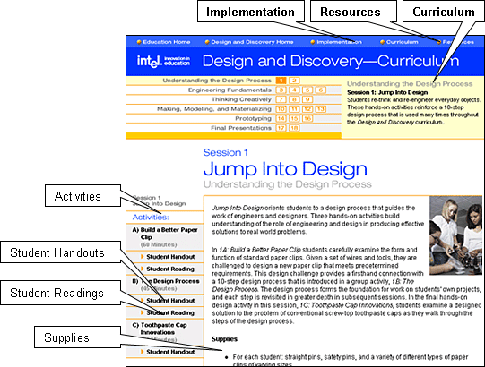

Key Points Notes
Time: 5 min. Slides 22–24

Explain that there are three main sections to Design and Discovery:

- Implementation—Covers organizing a program; using the curriculum; and participating in fairs

- Resources—Includes research sources; what engineers do (highlighting different engineering disciplines); additional activities that build on engineering and design principles; project examples; and information about how to interest girls in engineering

- Curriculum—Includes all other elements highlighted on the slide

Slide 25
Professional Development Workshops Support Learning With Technology
Intel® Innovation in Education Institutes are:
- A series of hands-on workshops delivered over the course of 2-3 days
- Designed for those responsible for providing professional development in effective use of technology to support student learning
- Delivered in a technology lab where participants experience the same active, hands-on learning that effective teachers provide for their students
- Led by experienced facilitators with backgrounds in classroom teaching, school leadership, and effective technology integration



Key Points Notes
Time: 3 min. Slides 25

Explain that the Intel® Innovation in Education Institutes are a series of hands-on workshops about the online tools and resources that were included in this Tour. The Institutes are delivered over a two- to three-day period to educators with staff development responsibilities.

Explain that the Online Workshops and Presentations section is a repository of all the materials needed to deliver an Institutes’ workshop, including facilitator slides, facilitator notes, and participant handouts.

Stress that all of the information and materials for delivering workshops are available online, free of charge, for anyone to use.

Slide 26
Wrap Up
Any questions?
- Where to find answers to your questions
- Next steps

Key Points Notes
Time: 5 min. Slide 26
Ask if there are any questions.

Wrap up the workshop.

Thank participants for attending.

