


Technology-Supported Learning with It’s a Wild Ride

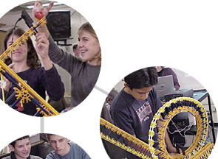

Technology-Supported Project Learning
It’s a Wild Ride

The Intel® Innovation in Education Institutes Web resources contain all the materials you need to present a successful workshop including:
- This document
- Participant handouts
- Workshop slides

These workshop materials assume that you:
- Have education experience in the classroom
- Have taken the workshop
- Have thoroughly reviewed and are familiar with the workshop resources
- Are familiar with the Intel® Innovation in Education Web site
- Are familiar with using the Internet
- Have a high-speed Internet connection to use during the workshop

Technical Requirements
To give the workshop, you’ll need a technology lab setting with high-speed Internet access and the following equipment:
- Presenter's computer equipped with:
- A high-speed Internet connection
- Monitor
- Computer projector
- VCR (connected to projector and speaker system)
- Wireless mike (depending on room size and acoustics)

- Computers with high-speed Internet connection for participants
(maximum of 2 participants per workstation)

For more information, on the computer requirements, see Site Recommendations www.intel.com/education/site_support/recommendations.htm

Preparation
Make sure you have spent time going over the It’s a Wild Ride resource before your presentation so you are familiar with its layout and content.

Day of the Presentation
Cue the video. Check and adjust audio.

Open two browser windows: one to the workshop slides and another to the It’s a Wild Ride Web page. You’ll toggle between these browser windows during the workshop.

Technology-Supported Project Learning
With It’s a Wild Ride

Goals
- Develop strategies for designing new projects supported by technology
- Learn strategies for project planning as an interdisciplinary team
- Explore methods that promote student self-management
- Learn about embedding assessment in project work

Agenda

Total Estimated Time: 2 hours

Topic | Estimated Time | Slide Numbers
- Welcome | 5 minutes | Slides 1–3
- Warm Up: Why Do Projects? | 10 minutes | Slides 4–5
- Overview and Goals | 5 minutes | Slides 6–7
- Video Introduction | 25 minutes | Slides 8–10
- Orientation to the Web Site | 20 minutes | Slides 11–13
- Hands-on Exploration | 30 minutes | Slides 14–15
- Developing Effective Projects | 20 minutes | Slides 16–17
- Wrap Up | 5 minutes | Slide18

Facilitator Tips During the Workshop

Slide 1




Key Points Notes
Time: 5 min. Slides 1–3

Display this slide as participants enter the room.

If appropriate, introduce yourself and have participants introduce themselves.

Slide 2
About Intel in Education
The Intel® Innovation in Education initiative:
- Has invested more than $700 million worldwide in education efforts through 2003
- Collaborates with leaders from education, governments, industry, academia, and research organizations
- Designs and delivers programs in more than 50 countries on six continents
- Gives teachers tools, strategies, and resources, free-of-charge, that they can use to make a difference in the classroom
This long-term, sustained initiative consists of several programs:
- Intel® Innovation in Education Web site
- Intel® Teach to the Future
- Intel Computer Clubhouse Network
- Intel sponsored science competitions
  - Intel Science Talent Search (Intel STS)
  - Intel International Science and Engineering Fair (Intel ISEF)
Key Points Notes
Time: 5 min. Slides 1–3

Provide an overview of Intel’s efforts in and commitment to education.

Slide 3
Intel® Innovation in Education Web Site
Intel® Innovation in Education home page
www.intel.com/education
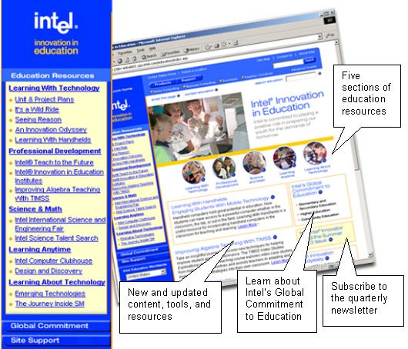
Key Points Notes
Time: 5 min. Slides 1–3

Display the Intel® Innovation in Education Web site home page to make participants familiar with it as a source of Intel resources for educators.

Point out the location of It’s a Wild Ride on the Intel Innovation in Education home page (in the left navigation under Learning With Technology).

Slide 4
Warm Up: Why Do Projects?
Think about a project of yours—a home improvement project, a hobby, or a community involvement effort.
Share Responses: To successfully complete that project, what skills, behaviors, and habits did/does that project require?
Look at list: Are there any skills, habits, and behaviors in this list that you would NOT want students to practice and develop?
Key Points Notes
Time: 10 min. Slides 4–5

Have participants think about a project—home improvement, a hobby, or a community involvement effort, for example.

Ask: What skills, behaviors, and habits does the project require for successful completion?

Open the Word* document from the link (Share Responses) on the slide and enter responses into the document.

Review the responses and ask: Which of these things in the list would you NOT want students to practice and develop?

Make the point: This is why projects are worth it. We need to provide rich contexts in which to practice and apply project work skills and habits. Sum up with this Estonian proverb:
The work will teach you how to do it.

Slide 5
Opportunities for Learning
While activity-based instruction focuses student learning on content knowledge, project-based learning provides rich contexts in which to practice, apply, and develop important skills and habits.
Well designed projects present students with complex, interconnected tasks requiring a range of skills (research, plan, organize, design) and habits (meet deadlines, persist, delegate).
The work will teach you how to do it.—Estonian Proverb
Key Points Notes
Time: 10 min. Slides 4–5

Mention the qualities of well-designed projects by using the points on the slide.

Slide 6
Overview and Goals
This workshop is about developing technology-supported projects using a very detailed case study of an interdisciplinary project on roller coaster design.
Goals
- Develop strategies for designing new projects supported by technology
- Learn strategies for project planning as an interdisciplinary team
- Explore methods that promote student self-management
- Learn about embedding assessment in project work

Key Points Notes
Time: 5 min. Slides 6–7

Present the goals of the workshop to set the stage for the concepts and activities to follow.

Slide 7
Agenda
Video Introduction
- Table of Contents
- View and Discuss
Orientation to the Web Site
- Navigating Features
- Common Questions
Hands-on Exploration
- What did you find?
Developing Effective Projects
- Strategies for Success
Wrap Up
Key Points Notes
Time: 5 min. Slides 6–7

Briefly present the agenda for the workshop to explain what will be covered.

Slide 8
Video Introduction to It's a Wild Ride
The video provides a general overview of It's a Wild Ride.
- Video is a "field trip" to three classrooms with an interdisciplinary project underway.
- It serves as a table of contents showing how information is organized on the Web site.
- The video segments match the Web site organizers.

Key Points Notes
Time: 25 min. Slides 8–10

Refer participants to the project information on pages 3 and 4 of their handout. Provide time for them to read both pages.

Introduce the case study briefly.

Slide 9
The It's a Wild Ride Video and Web Resource
The It's a Wild Ride video and Web site both have six main sections.
From the Intel® Innovation in Education home page, www.intel.com/education select It's a Wild Ride in the left navigation.
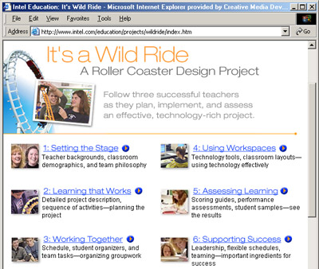 | - Setting the Stage  - Learning that Works  - Working Together  - Using Workspaces  - Assessing Learning  - Supporting Success

Key Points Notes
Time: 25 min. Slides 8–10

Explain that the It's a Wild Ride video is organized into the same six categories as the Web resources.

Point out that the video serves as a “table of contents” for the Web site categories:
- Setting the Stage
- Learning that Works
- Working Together
- Using Workspaces
- Assessing Learning
- Supporting Success

Slide 10
View and Discuss the Video...
Look for: What do you find useful?
Think about: What would you want to know more about?
After the video, share your questions:
What more do you want to know about the It's a Wild Ride project?
Share responses.
Key Points Notes
Time: 25 min. Slides 8–10

Direct participants to look for the following as they view the video.
- What do you find useful?
- Think about: What would you want to know more about?

Tell participants to make notes about their questions as they watch the video.

Show the video. (15 minutes)

After the video, collect responses to the question "What do you want to know more about?"

Open the Word* document by clicking on the link. Enter the responses and questions in the Word document. (As you enter a question, think about where answers to questions of this type are found on the Web site.)

Slide 11
Orientation to It's a Wild Ride on the Web
Finding Answers to Your It's a Wild Ride Questions
From the Intel® Innovation in Education home page, intel.com/education, select It's a Wild Ride in the left navigation.
- Setting the Stage—background, teaming
- Learning that Works—project contents, student work
- Working Together—daily calendar of project activities, red book, grouping
- Using Workspaces—technology tools, classroom maps
- Assessing Learning—student work samples; narrative on grades
- Supporting Success—block schedule, teaming, leadership
Key Points Notes
Time: 20 min. Slides 11–13

Review the navigation and general content in the six categories.

Refer to the primary questions participants asked after the video and direct them to look for answers in the appropriate category. (Examples: For planning time to develop projects, see Working Together. For home roller coaster construction, see Learning That Works and Assessing Learning.)

Slide 12
Navigating the Features of the It's a Wild Ride Case Study
Background information on the teachers, school, students
For example: teacher teaming or student demographics
Actual student work samples
For example: student journal entry
Detailed descriptions of learning activities in each classroom
For example: Design and Motion Investigations in Mathematics
Specific content standards for each subject area
For example: Science Learning Goals
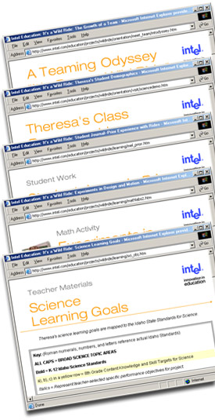

Key Points Notes
Time: 20 min. Slides 11–13

Show how to navigate and find features of It's a Wild Ride Web resources.

Slide 13
Answers to Common Questions
Questions related to the project schedule:

Visit Working Together and select Project Calendar.
Questions related to the home roller coaster:

Visit Learning That Works, and select Design Criteria.
Or visit Assessing Learning and select Performance Assessment.
Question related to the team roller coaster task:

Visit Working Together and select the Red Book.



Key Points Notes
Time: 20 min. Slides 11–13

Show how to navigate and find answers to questions in It's a Wild Ride Web resources.

Slide 14
Hands-on Exploration of Project Learning Model on Web Site
Browse It's a Wild Ride to learn more about:
- When and how these teachers plan the project
- What kinds of activities occur in each classroom throughout the project
- What strategies are used for organizing and managing group work
- How computer and non-computer activities are scheduled in this classroom
- How this project is assessed

Key Points Notes
Time: 30 min. Slides 14–15

Have participants explore It's a Wild Ride Web resources on the Intel® Innovation in Education Web site.

Organize the list of participants’ questions into the six categories and display the groupings to participants.

Move among participants answering individual questions and directing them to find answers using the reorganized list.

Determine if participants have questions after exploring for answers.

Prompt participants to tell you what they learn or find useful as they explore, and use their answers to gauge areas of interest, which will be useful when displaying the next slide.

Slide 15
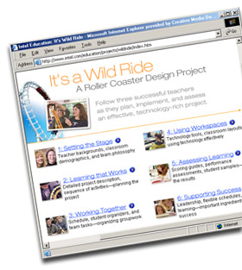
What Did You Find?
Share what you found:
What did you learn or find useful as you browsed the site?

Key Points Notes
Time: 30 min. Slides 14–15

Have participants share what they found and explain what was useful to them.

Record their responses in a Word* document or on a whiteboard.

Slide 16
Developing Effective Technology-Supported Projects

What can you generalize from the case study that might improve or assist with your project planning?
The categories used in It's a Wild Ride are useful organizers for high-level planning of any project. Working in small groups, discuss the questions on the handout organized in these categories.
- Setting the Stage
- Learning that Works
- Working Together
- Using Workspaces
- Assessing Learning
- Supporting Success

Key Points Notes
Time: 20 min. Slides 16–17

Emphasize that the next small group activity should help identify learning from the case study that can be generalized to the development of any project.

Point out that the six categories of It's a Wild Ride are useful organizers for planning any project at a high level.
- Setting the Stage
- Learning that Works
- Working Together
- Using Workspaces
- Assessing Learning
- Supporting Success

Have pairs or small groups discuss questions on the "Developing Effective Technology Supported Projects" handout.

continued on next page

Point out that there are two types of questions for each category listed on the handout:
- Questions related to the It’s a Wild Ride project
- Questions related to one's own classroom and projects

(If time is limited, assign one category to each group and have groups discuss the associated questions. Each group should share findings for their assigned category.)

Have participants share the strategies they came up with in response to the questions on the handout.

Slide 17
Strategies That Lead to Successful Projects

Share results of small group discussions:
- What strategies lead to a successful project, such as It's a Wild Ride?
- What will you take away from this workshop that will assist you in developing projects?

Key Points Notes
Time: 20 min. Slides 16–17

Have participants briefly share strategies they have learned from the case study and from each other.

Some additional areas for discussion:
- Developing projects (that balance academic rigor and a focus on standards with student control and expression)
- Issues and options with teaming and block scheduling
- Technology access and support
- Supportive leadership

Slide 18
Wrap Up
Any questions?
Please complete the online session evaluation
www.inteleducation.com/institute
Remember to take a copy of the video or order online.
Key Points Notes
Time: 5 min. Slide 18

If time allows, briefly show and explain other related resources on the Intel® Innovation in Education Web site that provide curriculum ideas:
- An Innovation Odyssey www.intel.com/education/odyssey
- Unit and Project Plans
www.intel.com/education/unitplans

Ask if there are any questions.

Wrap up the workshop.

Thank participants for attending.

Have participants complete the online session evaluation.

