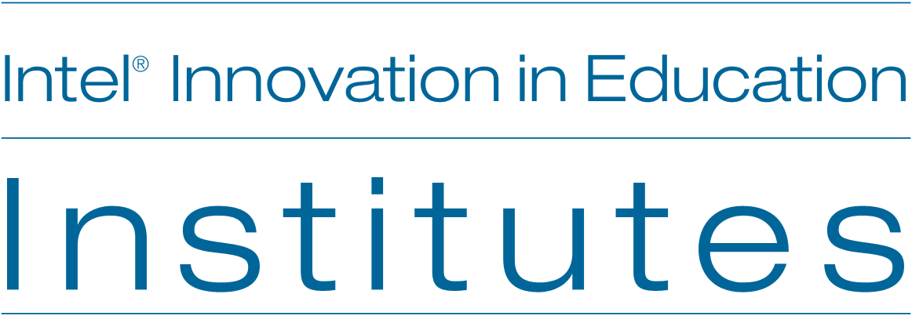


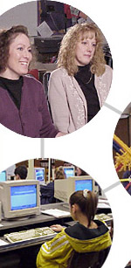
Technology Supported Project Learning with It’s a Wild Ride
Free Online Tools to Support Effective Instruction
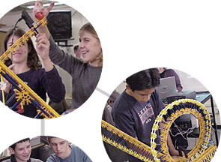

Technology-Supported Project Learning
With It’s a Wild Ride

Goals

- Develop strategies for designing new projects supported by technology
- Learn strategies for project planning as an interdisciplinary team
- Explore methods that promote student self-management
- Learn about embedding assessments in project work

Agenda

- Warm Up: Why Do Projects?
- Discussion: Why do project learning?
- Overview and Goals for the Workshop
- Video Introduction to It’s a Wild Ride.
- Orientation to the Web Site
- Hands-on Exploration of Project Learning Case Study on Web Site
- Developing Effective Projects
- Discussion: Strategies that support successful projects
- Wrap-up: Evaluations and video distribution

Technology-Supported Project Learning
With It’s a Wild Ride

It's a Wild Ride is an extended interdisciplinary project where students study roller coaster design in science, mathematics, and language arts classrooms. They learn about and apply laws of motion, linear and non-linear equations, and technical reporting. As the project unfolds, they move from learning content-specific knowledge and skills to applying what they learn in a group design task. Student design teams must convince the theme park owners to accept their design through persuasive presentations. It starts with an RFP!

Request for Proposals

The owners of the Canyon Amusement Park are seeking proposals for a new roller coaster ride. This coaster must thrill riders young and old with unique design features that incorporate the best in safety and engineering while providing an unforgettable experience. It's no secret that the Canyon Amusement Park is in desperate need of a new high-interest ride that will increase attendance.
Our goal is to attract roller coaster fans from near and far. The future of our local theme park rides on your ingenuity. We will accept proposals in eight weeks. Complete proposal criteria available upon request—serious inquiries only.
The Management, Canyon Amusement Park
T. Maves, M. Harris, J. Whitesell

With this challenge to save the local theme park, the stage is set for engaged learning!

The project is organized in five phases that generate knowledge:
Phase 1: Accessing prior knowledge about roller coasters.

Phase 2: Investigating content specific skills and knowledge with experiments in math and science that build understanding about force and the laws of motion.

Phase 3: Expanding knowledge of roller coaster design with research and further experimenting related to roller coasters.

Phase 4: Applying new knowledge to the design and construction of a roller coaster model.

Phase 5: Contributing knowledge to a group roller coaster design in one of four careers: engineering, architecture, research, or public relations.

It’s a Wild Ride Learning Objectives

A list of general objectives was defined as the team planned the project. They also outlined the level of mastery as Introducing, Practicing, and Mastery.

Science
- Describe force and motion principles using mathematical formulas and graphing. (P, M)
- Identify and explain Newton's Laws of Motion as they pertain to the project. (P, M)

Mathematics
- Accurately use appropriate measurements and conversions for project.
(P, M)
- Use science probes and graphing calculators to collect data and represent the data mathematically. (I, P)

Language Arts
- Use technical, persuasive, and research writing to explain projects developed. (P)
- Conduct research including using the Internet, databases, and
periodicals. (P)
- Correspond with an outside expert to enhance the project. (I, P)

Technology
- Create and use a database of information. (I, P)
- Create presentation materials enhanced by various technologies. (I, P)

Teamwork and Design
- Organize material and other resources, plan one's work, collaborate productively, chooses suitable tools and techniques, work with appropriate measurement methods. (P)
- Evaluate the ability of a design to meet criteria established in the original purpose. (I, P)
- Design a product taking into account needs and constraints. (I, P)
- Identify appropriate problems for technological design. (I, P)

Relevant Web Sites:

The Buck Institute for Education provides useful resources from background to project samples at its Web site: www.bie.org.

Project Based Learning with Multimedia The Challenge 2000 Multimedia Project (San Mateo County, CA) contains many useful curriculum and assessment examples: http://pblmm.k12.ca.us

A comprehensive overview of the research on project based learning, in a downloadable PDF document, is available at www.k12reform.org/foundation/pbl/research.

Developing Effective Technology-Supported Projects

Questions for Exploration and Discussion. Working with a partner, use these questions to guide your exploration of the It’s a Wild Ride Web resource. Take notes and be ready to share strategies you learn from this case study that will help you develop your projects.

Introduction
- After viewing the video, what do you want to know more about?
- What do you want to accomplish with project learning?
- What do you need to know?

Setting the Stage. Project planning and development are influenced by the culture and structures of the school and staff.
- What aspects of the school and classroom support effective projects?

Learning That Works. There are many things that make projects successful learning experiences for students—engaging tasks, open-ended results, real-world connections.
- What made this project a worthwhile learning experience for students?
- What project ideas does It’s a Wild Ride bring to mind?

Working Together. Effective project work depends on processes that keep students organized and self-managing, while providing greater control of their learning and greater flexibility in learning activities and results.
- What strategies were used for organizing and managing group work?
- How are computer and non-computer activities scheduled in this classroom and in your own?

Using Workspaces. Access, location, and arrangement of technology-based learning tools and other resources are important to consider when designing effective projects.
- What strategies did teachers use to take advantage and overcome disadvantages of the workspace arrangements for the project?
- What workspace opportunities do you have in your own school?

Assessing Learning. Extended projects often involve performance assessment or development of artifacts that represent learning—embedding assessment in project work.
- How was this project assessed? In what ways has the project contributed to student learning in this classroom?
- What has contributed to student learning in your classroom?

Supporting Success. Successful technology supported projects need support from broader school structures and practices, such as teaming and flexible schedules.
- In what ways do the school structures and practices support this project?
- What structures and practices in your school can you draw upon for project development and implementation?

