Intel® Teach Program
Thinking with Technology Course

Foster Critical Thinking and Collaboration Skills, with free Professional Development for K-12 Teachers

Look at ways to use the Internet in new and constructive ways with your students.

You’ll leave with a standards-based unit plan, support materials, and implementation strategies to improve and assess students' higher-order thinking with the use of free, online tools.

You’ll use one of three thinking tools from Intel Education, teacher productivity tools, and Web 2.0 technology.

Free tools are available at www.intel.com/education

Visual Ranking Tool: Identify and refine criteria for assigning ranking to a list; and then debate differences, reach consensus, and organize ideas.
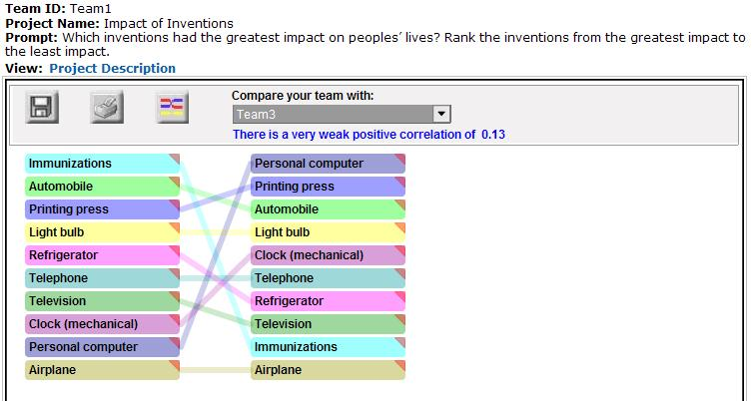

Seeing Reason Tool: Investigate relationships in complex systems, creating maps that communicate understanding.
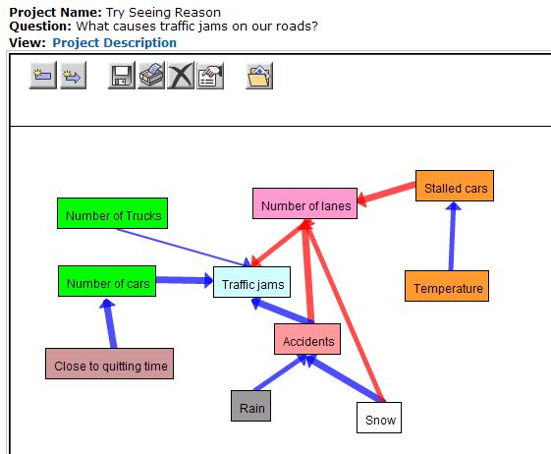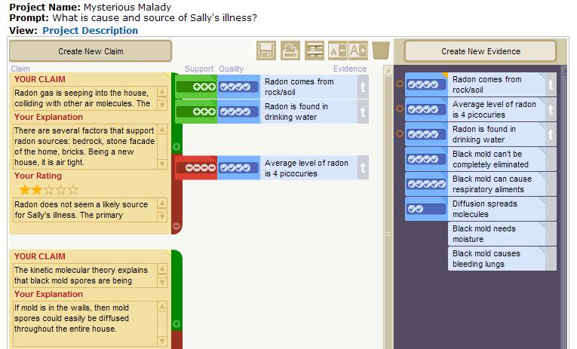
Showing Evidence Tool:
Construct well-reasoned arguments that are supported by evidence, using a visual framework.

Intel® Teach Thinking with Technology Course for Participant Teachers

Dates: Add the dates
Time: Add the times
Location: Add the location's address
Agenda: Visual Ranking, Seeing Reason, Showing Evidence – 24 to 40 hours
For more information, contact:

