Ordering Digital Guides for
Intel® Teach Essentials Course and Thinking with Technology Course

What is the Intel® Education Viewer / Intel® Teach Digital Guide?
The Viewer integrates all training components into one application for easy access (Course Guide, Help Guide, Course Resources); it is easy to use so even novice technology users will be successful with minimal training; users can save and retrieve or print data, preferences, and notes; users have the ability to change font size (per ADA readability guidelines), with flexible page widths)

Read about the Intel Teach Digital Guides (presentation)

There are 2 editions for a course CD, based on the operating system
(You will receive the default unless you request edition 2 from Customer Support. A prompt when your participants click the “Help Guide” tab will lead them through selecting the right Help Guide. If their version is not on the CD, they’ll find the right files on Intel’s public Web site – see the screenshot on page 2):

  Intel® Teach  Essentials Course | - Digital Viewer edition 1  (Microsoft Office 2007, 2003 & XP*, Apple Mac*)  - Digital Viewer edition 2  (Microsoft Office 2000*, Open Office, Apple Mac*)
  Intel® Teach  Thinking with Technology Course | - Digital Viewer edition 1  (Microsoft Office 2007, 2003 & XP*, Apple Mac*)  - Digital Viewer edition 2  (Microsoft Office 2000*, Open Office, Apple Mac*)

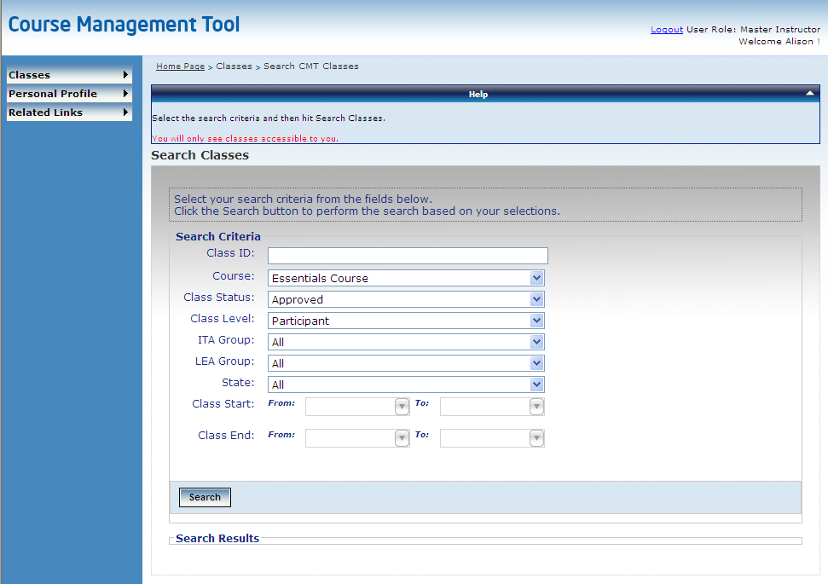
Ordering
In the Course Management Tool, http://coursemanagement.intel.com,

> click Classes
> Search Classes

Find your course in the list and click Edit.
- Click the Order/View Material link.
The default order is set for:
- Per participant: one CD of edition 1 (if you have 25 participants, you’ll receive 25 edition 1 CDs).
- Per class, one print manual for reference.

Print Manuals will continue to be distributed as long as they last. MTs request manuals by:
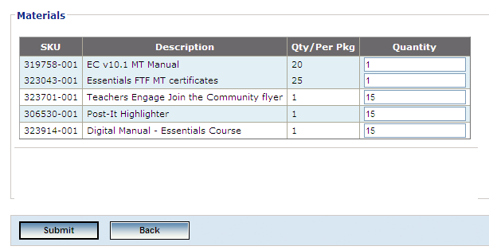
Changing the quantity of their order in the CMT:
- Increase the
quantity of the manual
- Reduce the quantity of the Digital Guide

- OR -

By emailing Customer Support

If any of your participants need Microsoft Windows Office 2000*or Windows Open Office*:
In their Digital Guide:
- Ask them to click “File” > “Select Help Guide Version”, and click the link to download the version of Help Guide they need.
- Refer them to the “Resources” tab > “Help Guide” section > “How to install a new Help Guide” document.

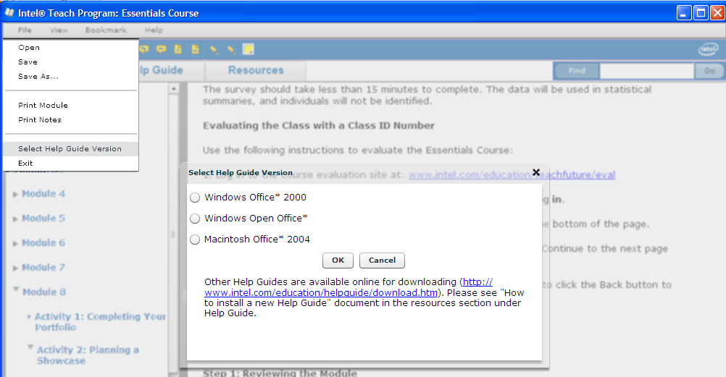

Senior Trainer and Master Teacher Course Resources
- Resources for print manuals are in Course Updates http://teachonline.intel.com/courseupdates
- Resources for the Digital Viewer will be in the Teachers Engage Online Community (http://engage.intel.com) – with streamlined presentations available in September.

